**Space for Chapter Logo**

JCI Anytown
P.O. Box xxxx
Anytown, MI 60000

Chapter Plan of Action

2022

Michigan

Evaluation Period*

☐ | Initial Submission
☐ | Quarter 1
☐ | Quarter 2
☐ | Quarter 3
☐ | Year End/Final Evaluation
☐ | Other: .
*To check the boxes, double click it and select “Checked”.
Table of Contents

Overview 3
Mission Statement 3
Vision Statement 3
Purpose Statement 3
Problem Statement 3
JCI ANYTOWN BOARD OF DIRECTORS 3
January Base Membership Roster 5
Chapter SWOT Analysis 5
SWOT 5
SWOT Strategies 5
Chapter Goals & Objectives 5
Planning Through Areas of Opportunity 7
Areas of Opportunity 7
Community Impact 7
Empower Members 9
Financial Planning 11
Collaborate with Partners 13
Marketing and Communication Plan 15
Calendar of Marketing: 15
Communications Plan: 15
Needs of Membership 16
Needs of Community 17
Business and Local Government Partner Evaluation 18
Membership Plan 19
Chapter Budget 20
2022 Calendar of Events 21
Attachments: 22

Overview

Mission Statement
Why do you exist?

Vision Statement
What is your vision for your chapter?

Purpose Statement
What is the purpose of your chapter? Can use JCI purpose.

Problem Statement

This should be a problem or hurdle you want to overcome this year. This is your primary focus goal at all times.

JCI ANYTOWN BOARD OF DIRECTORS

Name - President  Oversees all chapter activities  email | Name - Chairman of the Board  Advises President and board  email
Name - Vice President  Responsibilities  email | Name - Vice President  Responsibilities  email
Name - Vice President  Responsibilities  email | Name - Director  Responsibilities  email
Name - Director  Responsibilities  email | Name - Director  Responsibilities  email
Name - Secretary  Responsibilities  email | Name - Treasurer  Responsibilities  email

Note: Your chapter board may have different positions, more or less members. The purpose of this chart is to see and understand your BOD team and their responsibilities.

January Base Membership Roster
Name | Birthdate | Join Date

Chapter SWOT Analysis

SWOT
This should be done collectively at minimum by the Board of Directors; often you’ll have more buy-in from members if they are included in conducting a SWOT to help their voice be heard.

Strengths | Weaknesses
- Use a bulleted list structure  - These are internal factors | - Use a bulleted list structure  - These are internal factors
Opportunities | Threats
- Use a bulleted list structure  - These are external factors | - Use a bulleted list structure  - These are external factors

SWOT Strategies
Areas of overlap are evaluated to develop strategies that take advantage of the opportunities presented.
STRENGTHS/OPPORTUNITIES STRATEGIES (OVERLAP)
- EXAMPLE: Use our strong marketing to better promote our events
WEAKNESSES/OPPORTUNITIES STRATEGIES (OVERLAP)
- EXAMPLE: Use our members’ current professional successes to market the organization

Chapter Goals & Objectives
As your chapter is determining your chapter goals and objectives, we encourage you to determine how the UN Sustainable Development Goals fit into your projects. You will also see in the Areas of Opportunity there is a section to add which goal(s), your project is working towards.
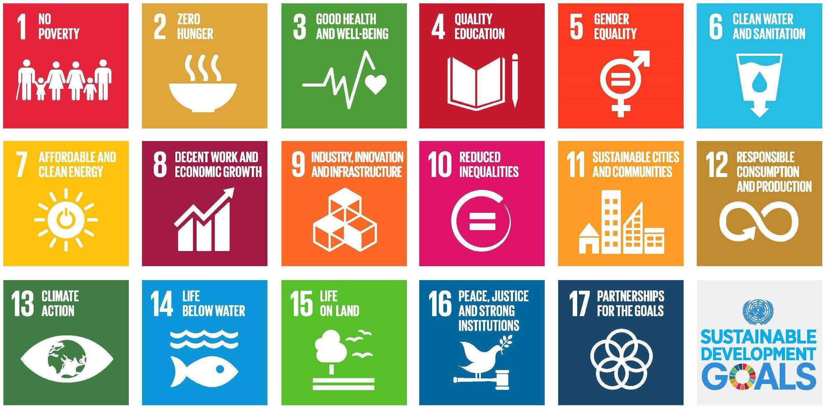

Long-term Goals 2+ Years: (What does your chapter want to look like in 2+ years)
- Goal One:
  - Objective to achieve defined goal
- Goal Two:
  - Objective to achieve defined goal
- Goal Three:
  - Objective to achieve defined goal

Short-term Goals – Current Year: (7-10 obtainable goals)
- Goal One:
  - Timeline:
  - Objective to achieve defined goal
- Goal Two:
  - Timeline:
  - Objective to achieve defined goal
- Goal Three:
  - Timeline:
  - Objective to achieve defined goal

Planning Through Areas of Opportunity

Areas of Opportunity
Using each of these areas, define what they mean for your chapter, how you’ll better them in the coming year, actions, challenges, and objectives needed to meet targets of these areas.
- Community Impact
- Empower Members
- Financial Planning
- Collaborate with Partners

Community Impact
JCI _______will enable communities to achieve sustainable impact.

- Goals | Tactic | Month/Date of Project | UN Development Goal

Expected Outcome:
What are you expecting your chapter hoping to accomplish with your community development goals and tactics?

Impact Area Pre-Evaluation Strengths and Weaknesses

Things We'd Like To Keep - they work well (Strengths):

Things We'd Like To Change (Weaknesses):

(To be completed on a quarterly basis. Please include revised strengths and weaknesses, results of listed goals, and project completion dates. – Replace text with aforementioned criteria – you may want to color code your quarters for easier reference)

Quarter 1

Quarter 2

Quarter 3

Year End/Final Evaluation

Empower Members

JCI _______ will create an environment in which
members are empowered to make positive change.

- Goals | Tactic | Month/Date of Project | UN Development Goal

Expected Outcome:
What are you hoping your chapter will accomplish to motivate, engage, retain and recruit members?

Impact Area Pre-Evaluation Strengths and Weaknesses

Things We'd Like To Keep - they work well (Strengths):

Things We'd Like To Change (Weaknesses):

(To be completed on a quarterly basis. Please include revised strengths and weaknesses, results of listed goals, and project completion dates. – Replace text with aforementioned criteria – you may want to color code your quarters for easier reference)

Quarter 1

Quarter 2

Quarter 3

Year End/Final Evaluation

Financial Planning

JCI ______will create a financial plan that invests in long-term goals.

- Goals | Tactic | Month/Date of Project | UN Development Goal

Expected Outcome:
What are you expecting your chapter will accomplish in achieving financial goals?

Impact Area Pre-Evaluation Strengths and Weaknesses

Things We'd Like To Keep - they work well (Strengths):

Things We'd Like To Change (Weaknesses):

(To be completed on a quarterly basis. Please include revised strengths and weaknesses, results of listed goals, and project completion dates. – Replace text with aforementioned criteria – you may want to color code your quarters for easier reference)

Quarter 1
Quarter 2

Quarter 3

Year End/Final Evaluation

Collaborate with Partners
JCI ________ will bring together like-minded partners in order to expand mutual impact.

- Goals | Tactic | Month/Date of Project | UN Development Goal

Expected Outcome:
How are you expecting your chapter to collaborate with other organizations?

Impact Area Pre-Evaluation Strengths and Weaknesses

Things We'd Like To Keep - they work well (Strengths):

Things We'd Like To Change (Weaknesses):

(To be completed on a quarterly basis. Please include revised strengths and weaknesses, results of listed goals, and project completion dates. – Replace text with aforementioned criteria – you may want to color code your quarters for easier reference)

Quarter 1

Quarter 2

Quarter 3

Year End/Final Evaluation

Marketing and Communication Plan
Goals:

Branding Development:
Ex. Increase name/logo awareness within community

Social Media:
Ex. Post multiple times a week, engage members and community

Communications Channels:
Ex. How do you community with members, the community, partners

Calendar of Marketing:
Table is just an example.
Event | Date
Print Postcards and Business Cards | January 2022
Mail Sponsorship Letters | March-May 2022
 | April
Order New T-Shirts for General Members | April
Order new shirts for Board of Directors | April/May
Monthly Meeting Promotion | ongoing monthly
Set up Facebook Event | Beginning of 2022
Set up MeetUp Event | Beginning of 2022
Internal FB Group Promotion | various
Set up Facebook Event | at least 2 weeks prior
Set up MeetUp Event | at least 2 weeks prior
Large Community Event | March 7, 2022
Set Up Facebook Event | February
Set Up MeetUp Event | February

Communications Plan:
Table is just an example.

 | Deliverable | Description | Delivery Method | Frequency | Owner | Audience
Internal | Monthly Meeting | Meeting to discuss upcoming projects and events, guest speaker | Meeting | Monthly | President | General Members and Guests
 | Needs of Membership | Survey of the Social, Community, Operations, Membership needs of the Chapter | Survey | Annually | President | General Members
 | Membership Renewals | Request Dues | Email | Monthly | Treasurer | General Members
 | Newsletter | Official Newsletter of the Ann Arbor Jaycees | Mailchimp/Email | Monthly | Newsletter Editor / COB | General Members
 | Board of Director Meeting Minutes | Minutes from recent meeting | Email | Monthly | President / COB | Board of Directors
 | New Member Orientations | Orientation about the Chapter to new members | Meeting | Quarterly | Membership Vice President | New Members
 | Updates | Updates about new members, monthly meetings, other events | Email | ≥ Monthly | President | General Members
 | Projects and Events | Community, Social, Fundraising, State Events | Email/Crier/ Social Media / Text | ≥ Monthly | President/Crier Editor/VPs/Committee Chairs | General Members and Potential Members
External | Social Events | Promotion and Updates | Email/ Meeting /Social Media/News Publications/ Phone Calls | Weekly | Project Chair
 | Community Events | Promotion, updates, and ticket sales | Email/ Meeting /Social Media/News Publications/ Phone Calls | Variable | Committee

Needs of Membership
What did you learn from your membership survey? Things to consider answering: What are your members hoping to accomplish this year? What types of projects do they want to run? Why are they members of your chapter?

Needs of Community
Insert evaluation of community needs, survey or results here.

Business and Local Government Partner Evaluation
Current Partners:
- EX. Boy Scouts – This organization we provide one fundraiser a year for them. We have the opportunity to leverage this organization to pull in parents to our organization.

Potential Partners:
- EX. City Commission – We need the buy in of these city officials to complete larger projects. We can start a relationship with them by having a representative at each city meeting and inviting them to ours.

Membership Plan
(Use this Membership Plan to help understand your membership recruiting needs. Once your needs are identified then plan your calendar of events around those difficult months. For example: If you have a lot of members due in the second quarter, then your chapter should be running a more programming this quarter prior and during to help offset members lost. For example – Socials, Community Fundraisers, Membership Drives, Networking Events, etc. Plan your calendar of events based off of this Membership Plan of Action.)

HOW TO USE THE MEMBERSHIP TABLE/SPREADSHEET:
- Input your January 1 Base Chapter Member number in the box under the “No. Members” Column for Quarter 1.
- Input the number of members due each quarter in the “Number Due” column. (This information can be found in the membership database, www.jayceemember.com, or request the information from a state officer.)
- Input the number of members that are up for renewal each quarter that you expect to retain their Jaycee membership in the “Number Retained” column.
- Input the number of new members you expect to gain each quarter.
- Insert the “Quarter End” number as the “No. Members” for the next month. (ie: If Quarter End = 20 for January, insert 20 for “No. Member” for February)
- The “Quarter End” number for December is the quantity of members you plan to have in the Chapter at the end of the year.

Current:
 | 2019 | 2020 | 2021 | Projected 2022
Beginning Membership | 50 | 51 | 50 | 55
Year End Membership | 51 | 50 | 55 | 60
Membership Gain/Loss | +1 | -1 | +5 | +5
New Members | 3 | 2 | 7 | 6
Member Drops | 2 | 3 | 2 | 1

Actuals
Quarter | No.Members | -Number Due | =Beginning Month | +Number Retained | +New Members | =Quarter End
1
2
3
4

Chapter Budget
(Below is an example of a budget. Feel free to use this template or insert your own.)

 | INCOME | EXPENSE
BUSINESS
Business-related Projects
Leadership Projects
Ways & Means Projects
Member Dues
Corporate Sponsorships
Insurance, Incorporation, Taxes, Audit
Public Relations
Chapter Newsletter & Brochure
Chapter Website & Hosting
Chamber of Commerce Membership Dues
Surveys
Miscellaneous Operations
TOTAL
Membership
Financial Planning Projects
Personal Skills Projects
Family Life Projects
Spiritual Development Projects
Chapter Socials
Chapter Awards
Write-Up/Speak-Up/Armbruster/Brownfield/Debate
Membership Recruitment
New Member Orientations
New Member Packets
Recruiting Incentives
Membership Training
Officer Training
Printing for Meetings
Miscellaneous Operations
TOTAL
COMMUNITY
Community Service Projects
Community Fundraising Projects
Governmental Involvement Projects
Children & Youth Projects
Miscellaneous Operations
TOTAL
Other
State & National Involvement Projects
International Involvement Projects
Miscellaneous Operations
TOTAL
GRAND TOTAL

2022 Calendar of Events
(Below is an example of a Chapter’s Calendar of Events. Insert your Meeting and Project Dates accordingly)

January 2022  3 - Third Trimester Competitions Registration  8 - BOD  15 - GMM  16 - Judgement Day  February  5 - BOD  18 - GMM  19-21 - JCI MI 2020 Year End Conference, Kalamazoo, MI  22- Chapter Plan due  March  4 - BOD  18 - GMM  April  1 - BOD  18 - GMM  22-25 - JCI USA 2020 Year End Conference, Billings, MT  May  6 - BOD  7-9 - JCI MI May Conference, Boyne, MI  20 - GMM  June  3 - BOD  17 - GMM | July  1 - BOD  15 - GMM  August  5 - BOD  19 - GMM  September  2 - BOD  16- 19 - JCI USA Annual Meeting/Celebration of the Century, St. Louis, MO  October  7 - BOD  21 - GMM  November  4 - BOD  18 - GMM  December  2 -BOD  16 - GMM  31 - T3 Close Out

Attachments:

Delete this page, or provide a separating Title Page/Index for Attached Documents. You can list the page as “Appendix” and provide a list of contents. In your Table of Contents, all you would have to list is “Appendix” and refer to this page number. If you forgo the Appendix/Index on this page, then list the documents attached individually in your Table of Contents.

ATTACH THE FOLLOWING DOCUMENTS:

- Chapter Constitution & Bylaws
- Chapter Incorporation (A copy of your chapter’s incorporation papers)
- Liability Insurance (A copy of your Insurance Policy Notice)
- A screen shot or copy of tax form 990 completed

Suggested Attachments:
- Member Survey or Survey Results
- Any other documents you use to plan your year
- Year-End Reporting which includes:
  - Summary and evaluation letter from the President
  - Final Budget

