Parts of a Chapter/Strategic Plan
- Board Directory – This is not only helpful to have all contacts in one place but state board members can easily find whom they need.
- Mission and Value Statement – Why do you exist and what will you look like in 5-10 years.
- Problem Statement: This should be a problem(s) that you want to overcome this year.
- SWOT Analysis: Strengths, Weakness, Opportunities and Threats (Also look at competitive advantage, what are you doing best, what attracts members, what does your Jaycee group do better than any other local civic group)
- Goals
  - Long-term (2+ years) – What will your group look like in 2+ years
  - Short-term (current year) - 7-10 is an obtainable number for short-term goals
- Objectives – What are key activities that you need to perform in order to achieve your vision? (Usually same as goals)
  - Strategies – Each objective will have 1-3 strategies to complete that goal
  - Tactics – Specific action items that need to be completed for the strategies
- Marketing Plan
- Needs of Membership (survey)
- Needs of Community (survey or evaluation)
- Community/Business Partnership Evaluation
- Yearly Budget
- Yearly Membership Plan – See Appendix O
- Calendar of events/projects
- EVALUATION

A Chapter Plan is a working document. It should be updated as you go. Consider it a living document of what works and what didn’t work for the year. Don’t forget about evaluation each trimester regarding the areas of impact and your goals.

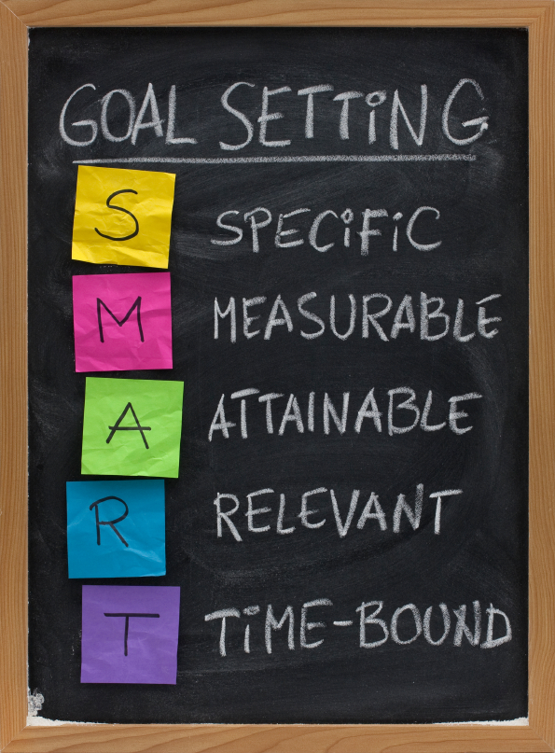

Eight Ways to Ruin Any Strategic Planning Training Meeting
Inviting everyone
Neglecting to conduct any research before the meeting
Holding an annual retreat
Getting through the agenda no matter what
Assuming everyone thinks like you
Ignoring the elephant in the room
Ending on a low note
Overlooking life after the meeting

Additional Thoughts on Follow Up
- Within a week after your strategic planning meeting, send out a timeline that contains the next steps and deadlines for completing the plan. Make sure to communicate this timeline to everyone in your organization so your employees know what is happening with the strategic planning process.
- Send out the strategic plan on the deadline you set, regardless if it is complete or not. As with the previous tip, you reinforce the importance of the plan.
- Post a visible result of the planning session in a common area. Items to post include your mission, vision, and values statements or a poster of your strategic plan.
- Do not, under any circumstance, cancel the next meeting in your planning or implementation process. As the leader, you are responsible for setting the example that the strategic plan is important. Canceling a meeting signifies it is not important. After all, execution is arguably more important than the planning itself.
- Roll out your strategy by communicating it to everyone in the organization

Planning Pitfalls
Strategic planning is as much about planning as it is about execution. Avoid these planning pitfalls and you’ll have a strategic plan that is a living, breathing document.
√√Lack of Ownership: The most common reason a plan fails is lack of ownership. If people don’t have a stake and responsibility in the plan, it will be business as usual for all but a frustrated few.
√√Lack of Communication: The plan doesn’t get communicated to employees, and they don’t understand how they contribute.
√√Getting mired in the day-to-day: Owners and managers, consumed by daily operating problems, lose sight of long-term goals.
√√Out of the Ordinary: The plan is treated as something separate and removed from the management process.
√√An Overwhelming Plan: The goals and actions generated in the strategic planning session are too numerous because the team failed to make tough choices to eliminate non-critical actions.
√√A Meaningless Plan: The vision, mission and value statements are viewed as fluff and not supported by actions or don’t have employee buy-in.
√√Annual Strategy: Strategy is only discussed at yearly weekend retreats.
√√Not Considering Implementation: Implementation is not discussed in the strategic planning process. The planning document is seen as an end in itself.
√√No Progress Report: There’s no method to track progress. No one feels forward momentum.
√√No Accountability: Accountability and high visibility are needed to help drive change. This means that each measure, objective, data source and initiative must have an owner.
√√Lack of Empowerment: While accountability may provide strong motivation for improving performance, employees must also have the authority, responsibility and tools necessary to impact relevant measures. Otherwise, they may resist involvement and ownership.

Guidelines for a Good Strategy
Need a quick check to see if your strategy is sound? Here are the guidelines for a good strategy. Make sure that your strategy…
√√Establishes unique value proposition compared to your competitors
√√Is executed through operations that provide different and tailored value to customers
√√Identifies clear tradeoffs and clarifies what not to do
√√Focuses on activities that fit together and reinforce each other
√√Drives continual improvement within the organization and moves it toward its vision

Impact

_______ Junior Chamber will enable communities to achieve family impact.

Creating sustainable impact is important because it leads to a world where human security is a reality for all global citizens.
Goals to be achieved in this category:
- Have 5 general members that have not previously chaired or co-chaired a project chair or co-chair a project by year end.
- Assist the Boy Scouts in running a fundraiser that raises funds of $500 or more towards their members or organization.

Action Steps:
- Develop a mentor program (ability to utilize senators and other aged out members)
- Create 5 new relationships with community organizations through board member interactions and plans.
- Put in place a Boy Scout Liaison to attend Boy Scout meetings and plan programming we can help support them with.
- Start a community garden; this will involve a different group of community members. Through forums and the garden itself, we can bring a new and different impact to the community that is not currently present.
- Community Survey – On Jaycee Website-
  - FoodPride to use bag inserts
  - Social Media blast regarding the survey
  - Easter Egg Hunt

Expected Outcome:
By the end of 2015, ________ Junior Chamber Members will have increased their impact by conducting projects. These projects impact the community through free activities, empowering young people and empowering more members.

Goal #__
Objectives | Tasks/  Activities | Timeline | Lead Role | Strategies Used | Measure /  Document | Resources needed
Action plans basically translate the Strategic Plan into implementation steps. Some Counties may put these two items (Strategic Plan + Action Plan) into one document, others keep them separate. Ideally the people who will be responsible for implementing the plan are involved in developing the Strategic Plan. Use a cross-functional team to ensure the plan is realistic and collaborative. A few tips about Action Plans:
􀀹 Organize the overall strategic plan into smaller action plans for each objective.
􀀹 Specify who is doing what and by when.
􀀹 While these may be separate documents, keep them linked in everyone’s mind.
􀀹 Build in regular reviews of status of the implementation of the plan.
􀀹 Translate the strategic plan’s actions into job descriptions and personnel performance reviews, especially for key leaders.
􀀹 Communicate the role of follow-ups to the plan. If people know the action plans will be regularly reviewed, implementers tend to do their jobs before they’re checked on.
􀀹 Be sure to document and distribute the plan, including inviting review input from all.
􀀹 Be sure that one internal person is identified as the lead in managing implementation.
􀀹 Integrate the plan’s goals and objectives into the chief executive’s performance reviews.

YU
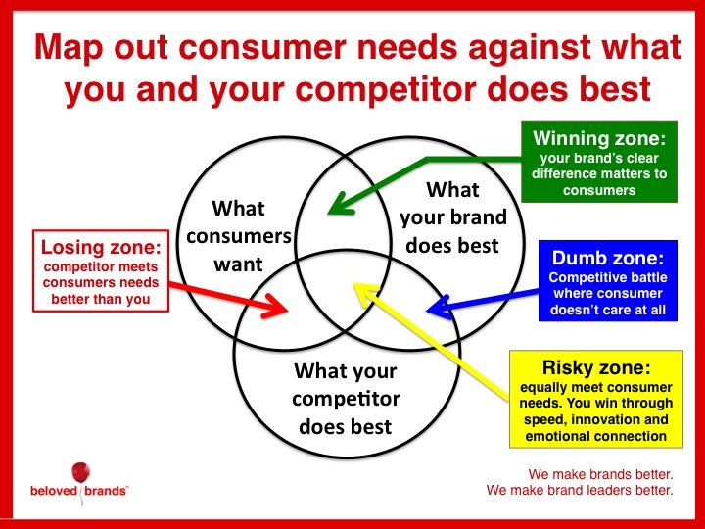
Use this to find our chapter’s Winning Zone!
Before You Start
Three questions to answer and remember as you go along with your chapter planning.
- Where are we now?
- Where are we going?
- How will we get there?
So here are some questions to prompt you and your team to think strategically about next year. Use them individually, or as a group exercise ahead of your next strategic planning session:
- What is the one thing your organization was worst at this year? What single thing most needs to happen to fix it?
- What is the one thing your organization did best this year? What do you need to do to turn that success into a repeatable process?
- Which individual was most responsible for standing in the way of your organization's success this year? What are you going to do about it? (This speaks to maybe a city council member is putting a halt to your ideas, etc)
- Which individual was most responsible for your organization's success this year? What are you going to do about it? I.e. did someone go above and beyond last year? How can you incorporate their talents into your business plan?
- Which area of concentration was most responsible for your organization's success this year? What are you going to do about it? i.e. was it fundraising that supported all your projects or did your community projects cause an membership increase
- What is the single metric you will measure your success by (not how anyone else will measure your success-- how you will measure your own success). What are you doing about it? I.e. funds donated or members gained

Ideas for Goals:
Here is a list of goals to help you in your planning process. These lists are not comprehensive. You may add or delete goals as you see fit.
• To conduct ____ public relations projects
• To participate in ____ parades
• To run ____ PSAs on television/cable access/radio
• To appear in the local newspaper at least _______ a month
• To create/update the chapter’s brochure
• To create/update the chapter’s website (update at least once a month)
• To produce a chapter newsletter once a month
• To meet all submission deadlines for the USJC CLC program
• To conduct evaluations of the chapter plan within 30 days of the end of each quarter
• To submit ____ Mid-Year Evaluation
• To submit ____ Annual Report
• To conduct ____ Project Management Guide (PMG) trainings
• To conduct ____ Single Project Entry (SPE) trainings
• To get completed community surveys from ____ members of our community
• To review and renew chapter insurance policy
• To file incorporation papers
• To file taxes
• To provide monthly breakdown of cash and accounts receivable
• To provide ____ written financial reports to the general membership
• To conduct ____ ways and means projects with a total net profit of $__________
• To end the year with $________ in the bank
• To become a member/renew membership with local Chamber of Commerce
• To have ____ local business members speak at General Membership meetings
• To conduct ____ Entrepreneurs Program modules
• To conduct ____ Value Investing seminars
• To conduct ____ Career Advancement trainings
• To conduct ____ other business opportunities projects
• To conduct ____ financial planning projects
• To conduct ____ personal skills projects
• To conduct ____ family life projects
• To conduct ____ spiritual development projects
• To have ____ members compete in Local/Regional/State Speak-Up Competition
• To have ____ members compete in Local/Regional/State Write-Up Competition
• To have ____ members compete in Armbruster/Brownfield Competition
• To have ____ members compete in Jaycee Debate Competition
• To conduct ____ Chairperson trainings
• To have ____% of officers attend state/region-sponsored training (i.e.: LOTS, ROTS)
• To conduct ____ Parliamentary Procedure trainings
• To conduct ____ member surveys
• To get completed membership surveys from ____% of our members
• To conduct ____ new member orientations
• To advance ____% of the membership one or more Degrees in the Passport to Civic Leadership program
• To retain ______% of the membership
• To provide incentives to members for recruiting
• To conduct quarterly recruitment drives
• To set up ____ membership booths at various community functions
• To conduct ____ corporate sponsorship meetings/projects
• To create a membership packet
• To create a letter welcoming new members to chapter
• To complete _____ internal extensions
• To complete _____ new chapter extensions
• To hold ____ socials
• To conduct a chapter awards program
• To conduct _______ chapter visitations
• To participate in ____ Region events
• To participate in ____ State events
• To conduct a once-a-month Board of Directors meeting
• To conduct a once-a-month General Membership meeting
• To provide agendas for __________ Board of Directors meetings (minimum of twelve)
• To provide agendas for __________ General Membership meetings (minimum of twelve)
• To record and distribute minutes for _______ Board of Directors meetings (minimum of twelve)
• To record and distribute minutes for _______ General Membership meetings (minimum of twelve)
• To conduct ____ youth projects
• To conduct ____ underprivileged projects
• To conduct ____ elderly projects
• To conduct ____ community improvement projects
• To conduct ____ community fundraising projects raising $____________
• To conduct ____ governmental involvement project(s) during the year
• To conduct ____ visitations to City Council meetings
• To conduct ____ state involvement projects
• To conduct ____ national involvement projects
• To conduct ____ international involvement projects

