The Mechanics of Membership and Growth
The mechanics of chapter growth are the easy part! Calls are made to members to see if they’ll renew, and new members are recruited using a five-step process in the recruiting section. All Board members should review the membership roster and dues payments. They should know who will and will not renew and the reasons for those decisions.

Real chapter growth, however, is a step or two beyond the mechanics. It involves asking and answering the following questions:
- What is the progress of the chapter plan?
- Are members participating?
- Are members complaining?
- Do members seem satisfied with projects and project assignments?
- Are Board members serving the members?
- Are Board members promoting the ultimate goals of the chapter?
- Real chapter growth has two components: 1) number of new members, and 2) scheduled activities and real results. The following questions should be asked and answered:
- What is the chapter’s image in the community?
- Does the community turn to the Junior Chamber for help?
- Real chapter growth also involves the lasting effects involvement has had on past members. The following questions should be asked and answered:
- Did being a member of the chapter give past members the skills they needed to get a better job?
- Did their involvement make them better citizens?
- Did their involvement give them the courage to stand and be counted?
- Did their involvement give them more confidence in taking and completing tasks?

Note: True chapter growth is not a year-long goal. It is a lifetime goal for the chapter. A member’s improved standing in the community should be indicative of personal growth. After all, the Junior Chamber is all about learning and improving ourselves and our communities. The only way we truly achieve this improvement is by practice. The results are worth it. The best gift a chapter can give a community is a better, more involved citizenry.

To Grow
The steps to growth include the following:
- Determination of the chapter’s membership needs
- Development of a plan that follows chapter objectives
- Scheduling of activities to meet the plan
- Following through with scheduled activities

The first growth step involves the determination of the number of members the chapter will need to fulfill objectives. Officers should look at the chapter’s calendar of events and determine whether enough manpower is available to accomplish scheduled activities. This should be

reviewed along with a roster listing the names of members and renewal dates. The membership plan (which is part of the overall chapter plan), should also be reviewed.
The objective is best illustrated by this example: the chapter will run several projects requiring a lot of manpower; however, several current members will soon reach age 40 and exhaust their membership. Schedule membership activities now, along with the planned chapter projects, to ensure the chapter doesn’t suffer from these losses.
The following are useful membership activities:

RECRUITING
Recruiting follows the basic rules of salesmanship, which include:
- Listen to those you are trying to recruit
- Be honest
- Be yourself
- Know the product
- Keep a positive attitude

Techniques vary, but the rule of thumb should be to choose a comfortable technique. The more comfortable a person is with his or her presentation, the easier recruiting will be.
The following steps are used by most successful recruiters (and salesmen!):
- Introduce yourself and your chapter.
- Find out information about the prospect that will help you match the interests of the Junior Chamber to those of your prospect.
- Talk about the Junior Chamber, using information learned in step two.
- Get the prospect to agree with you about how the Junior Chamber is important to the community and the individual.
- Ask the prospect to join, fill out the application, and ask for dues money. Ask for referrals, too.

If the prospect is reluctant, offer to pick him or her up for a chapter meeting or event. It is easier to recruit if prospects can see the immediate results of the chapter’s efforts. An excellent training tool for new members is to send them recruiting with a long-term member, allowing them to learn first-hand.

THE REFERRAL SYSTEM
The referral system simply refers to the use of lists of prospective members provided to the recruiter by others. Anyone can provide a referral, including those who decline the invitation to join. However, referrals won’t work unless follow-up work is done!
Sources of referrals include:
- Current members. This includes individuals they work with, attend church with, family, friends, neighbors, etc.
- New members.
- Business leaders. This includes the names of employees, managers, or business owners who might benefit by joining the chapter.
- Welcome Wagon. This can provide access to new residents in the community.
- • Membership booth. This can be located in an area with heavy pedestrian traffic.
- • Voter registration lists. These can be obtained from the county courthouse and used for a mass mailing.
- • Assign several Jaycees to promote the chapter to the public during every Community Area of Opportunity project.
- • The mayor, city servants, and ministers.

The chapter can:
- Ask for referrals when recruiting.
- Conduct a community survey.
- Sponsor a sweepstakes for a popular toddler’s toy at a local business. Ask for parents’ names, addresses, and phone numbers on the entry forms so that follow up with a personal visit or phone call can be scheduled. Allow only adults to complete the forms. Also, include an age bracket question (under 21?, 21 to 39?, 40 and over?), and ask if they would be interested in hearing more about the Junior Chamber. Follow these up with personal visits or phone calls.

CONTESTS AND INCENTIVES
Recruiting can be promoted through contests and incentives for members. These need not be complex or expensive. The most important step when developing an incentive program is to identify the types of incentives that will interest the members.
Free incentives might include:
- A personal letter from the mayor or governor
- Recognition in the chapter, district, region, or state newsletter
- Special parking at meetings
- Name mentioned in a letter to the editor of the local newspaper
- Free lawn care for a month
- Free home paint job
- Incentives the chapter might pay for include:
  - Gifts, plaques, pins
  - Tickets to a sporting or arts event
  - Registration to a state Board meeting

A Guide to Successful Membership Nights

The primary purpose of an M-night is to sign new members. The ultimate goal of Jaycees is to develop leadership skills. You can accomplish both with a well-planned and organized M-night project. Membership nights are meetings or events designed specifically to encourage people to join your chapter. They can be abbreviated meetings with a speaker, or simply special events to allow prospects and new members to meet in a relaxed setting. They also provide an opportunity for long-time members to become acquainted with new members. Remember, however, this is a side benefit. The primary purpose of an M-night is to sign new members.

To ensure a successful M-Night:
- Plan it like a project. Identify members who wish to serve on the M-night project committee.
- Decide what type of meeting you will conduct; a social or one with a motivational speaker.
- Establish the date, time, and place. Ask and confirm a guest speaker.
- Promote your M-night a minimum of 30 days in advance. Do publicity blitz. Your members must hear it three times and see it in print twice before they will retain it. Report on it at meetings; promote it with fliers, television, radio, newspaper, bulletin boards, postcards, and newsletters.
- Get personal commitments from members to invite prospective members. Ask for the names of their guests.
- Encourage your members to bring their prospective members. Do not expect prospects to come if they are not picked up. Prospects have a fear of the unknown. They do not know exactly what will happen and usually don’t know any of the people that will be there. Members must pick them up.

Ways to make the meeting FUN:
- Have a greeting committee. Personally welcome every attendee. Smile!
- Give everyone a name badge. Use one color pen for members and a different color for prospects.
- No clumping! Ask all members to talk to every prospect. Prospects are easy to identify if everyone has the special colored badges.
- Never allow a prospect to stand alone.
- Tell your members who were not sworn in before that they will have the opportunity to do so at this meeting. Ask them to come forward when asked after the meeting is convened. This will encourage the prospective members who want to join to come forward too.
- After being sworn in, give the new members something. A pin, booklet on Jaycees, newsletter or a membership roster is some items that may be used.

Other creative ideas are:
- Use a theme such as July 4th or Mardi Gras.
- Attractively printed and personalized invitations are effective.
- Call the meeting “Bring-A-Friend” night and ask your members to do that.
- Distribute a flier promoting the date and location of the orientation for those who join at the M-night.
- Don’t charge a prospect for anything at the meeting.

Things to do after the meeting is adjourned:
- Ensure the prospective members complete and return their membership applications.
- Ask for their dues payment. If they joined, they know they must pay. Just ask.
- If some who joined didn’t bring their checkbooks, give them a self-addressed, stamped envelope to mail their dues check in.
- Continue to encourage prospects that didn’t get sworn in to join. Sometimes they’re afraid to go up front.

Some follow-up suggestions for people who didn’t attend the meeting or didn’t join:
- Put the names of all these people on a Prospective Member Follow-Up Form and add them to your chapter’s newsletter list.
- If they didn’t come, mail them a postcard explaining that you missed them.
- If they did come, thank them for taking time to attend.
- Call and invite these people to another meeting or project.
- Smile, be friendly, and keep asking!

Some follow-up suggestions for people who joined:
- The President writes a letter or postcard welcoming them as members including the date, time, and place of the next meeting and event.
- Call them before the next event and invite them to attend. Pick them up!

Sample M-night Agenda
Time to allow for each activity:
Committee members arrive early to set up the room. Greeters arrive and set up welcoming table.
- 30 minutes prior to the program. Guests begin to arrive and are welcomed. Guests and members mingle. Refreshments may be served.
- Program: 30 minutes maximum. Stop serving refreshments during the meeting. Call to order, invocation, pledge to the flag, welcome, introduction of guests, explanation of purpose and a brief outline of chapter activities.
- Allow 10 minutes additional if you have a speaker. Speaker’s presentation.
- After the speaker, take a 15-minute recess to personally encourage prospects to join. Ask current members to mingle, answer questions, and explain what will happen during the swearing-in ceremony.
- Allow 10 minutes to swear in those who have decided to join. Ask all people (not just people joining tonight) who haven’t been sworn in to come forward.
- Allow plenty of time for people to mingle and one-on-one recruiting with those who have not joined.

Additional Membership Resources

The Michigan Jaycees Document Library (http://www.jcimi.org/document_library) and the United States Jaycees Document Library (http://www.jci.cc/local/info/usa/ourlibrary) have many resources to assist you throughout the year. If you have questions, have trouble find something, or need assistance, please don’t hesitate to call Membership Vice President Sarah Ellis or your District Director. We are here to help you!

The following resources are included in this handbook:

- Local Action Guide: Membership Growth
- Prospective Member System
- Local Action Guide: Membership Retention
- Member Survey (Sample)
- Passport to Civic Leadership Program Guide
- Chapter Membership Plan Form
- Chapter Extension Process
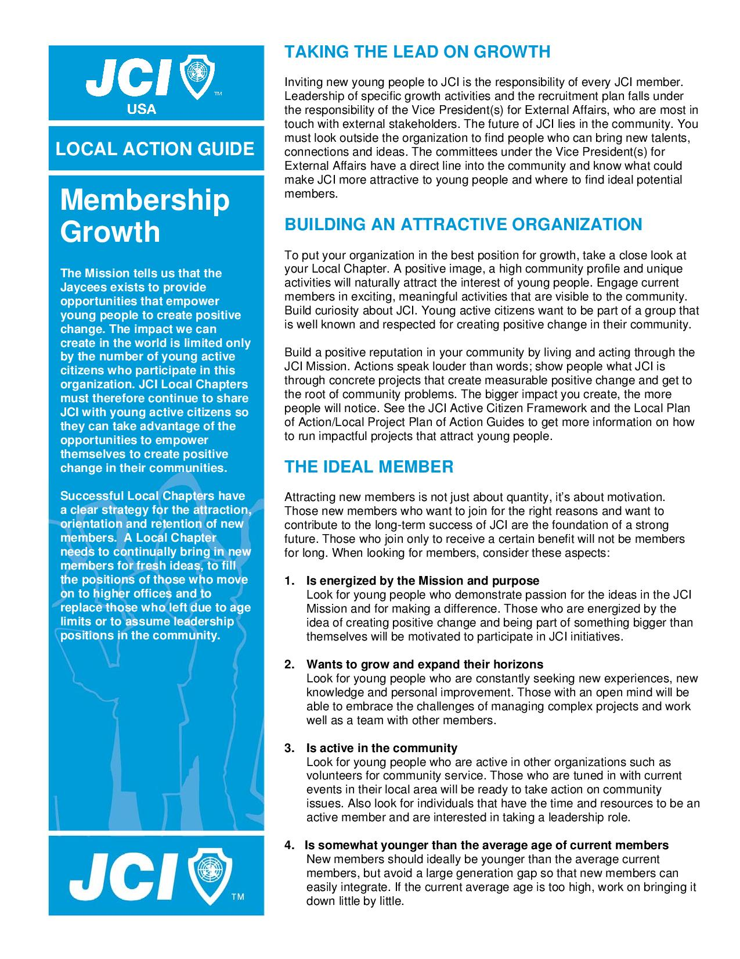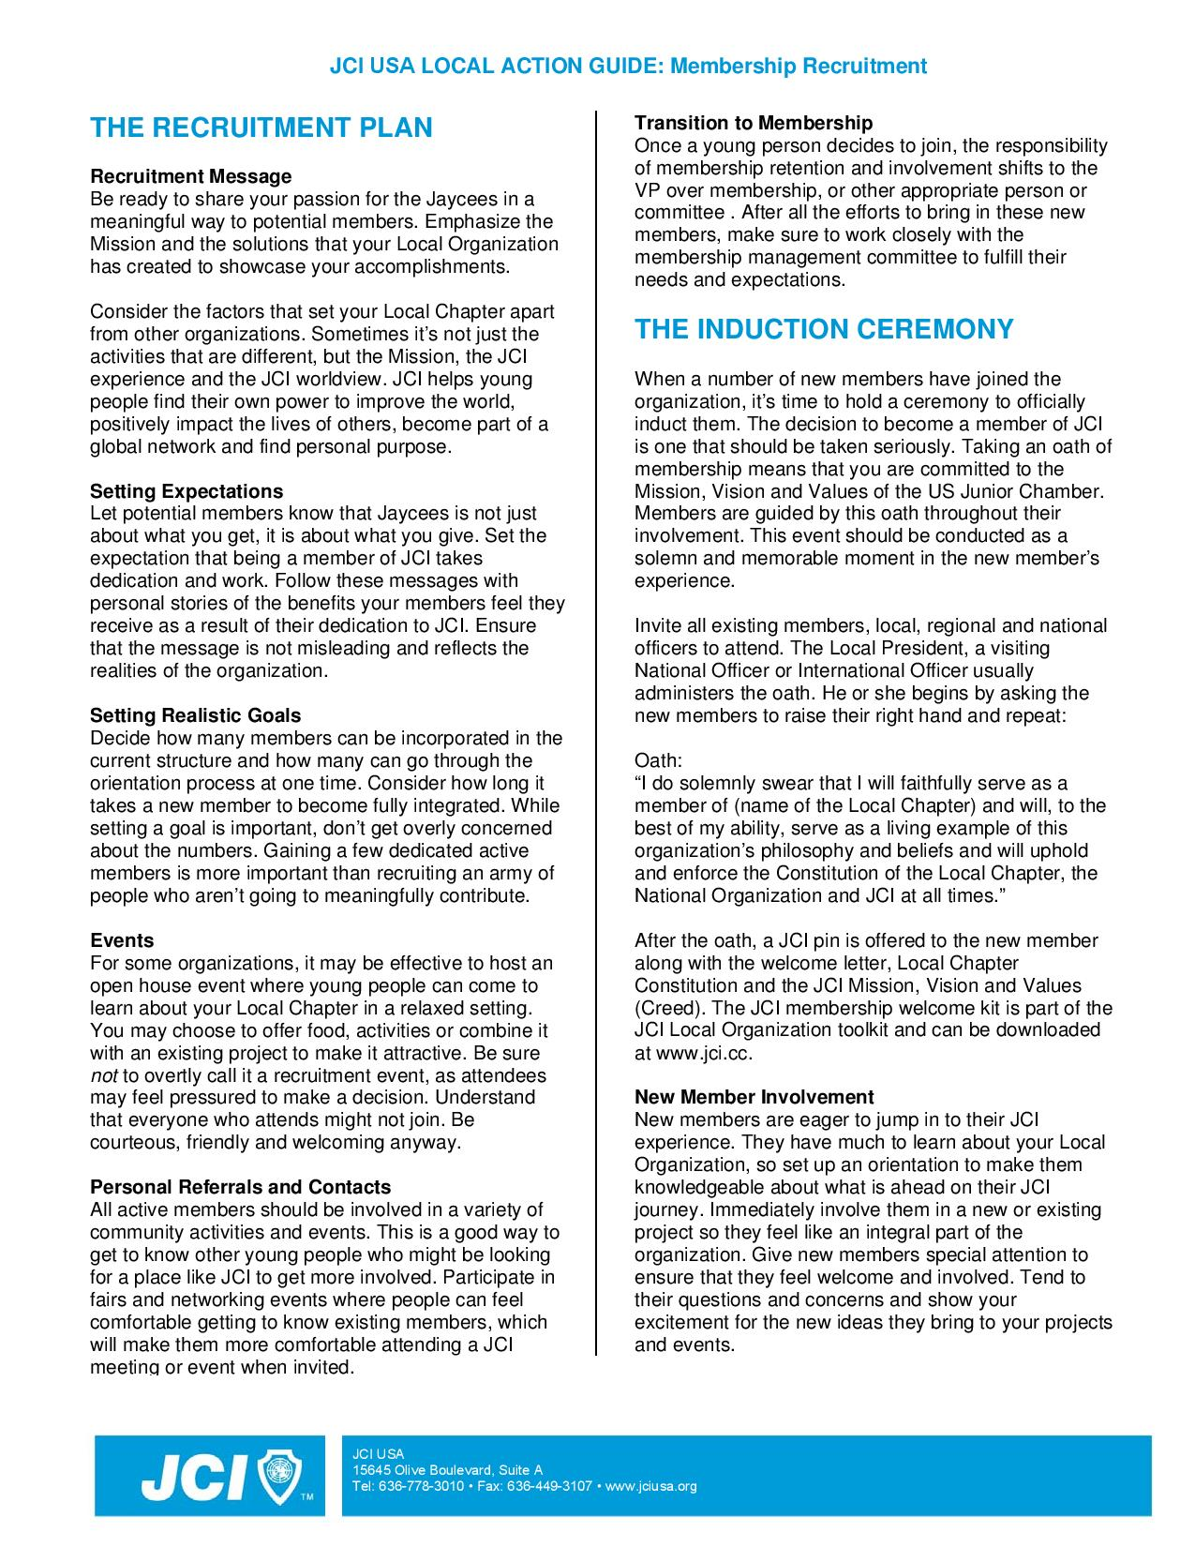
Prospective Member System

The Theory
The basic assumption of any effective membership recruitment system is that the challenge of finding and recruiting new members is an on-going one. An organization such as the Jaycees needs the injection of new members constantly to be successful. The new ideas, talents and friendships of new members are the key to the development and growth of any local chapter.

The Problems
- Many chapters concentrate their recruitment efforts in the last few days of every month. At month-end, we are often faced with trying to find that one member that will put us at growth.

- Recruiting responsibilities are too often placed only on the Local President and Membership Vice President.

- Most of our members are NOT talented “closers”.

- Most chapters tend to only recognize the membership “closers”.

- Most chapters never develop an incentive program to encourage non-“closers” to bring potential members to chapter functions.

The Prospective Member System Solution
1. Build a Membership Team
This TEAM should meet to organize the effort and come up with creative ideas for M-Nights and incentive programs. Sitting around a table and sharing creative ideas can be the most fun part of any project. Listen to everyone’s ideas, no matter how crazy they may sound, then direct the TEAM to come up with workable ideas and solutions and plan M-Nights.

2. Design a Prospective Member Plan
This plan should address how the TEAM will find, track, and approach prospective members for your chapter. Suggestions include: Add all Perspective members to your newsletter list. Send them a prospective member packet that include a letter explaining to them what your chapter is all about and thanking them for their interest in the Jaycees; a schedule of upcoming events; history about your chapter and the impact you have made on your community; and a list of contacts in the chapter and their roles. Set up a phone committee for contacting prospective members prior to M-Nights and significant chapter events. Always design a fun and exciting flyer or postcard and mail them to perspectives along with a map to the event. Develop a criteria for evaluating prospective members on a regular basis. Some people will never join, so have a method for removing them from the system, but don’t take them off too early!

3. Develop an Incentive Program
Incentive programs should recognize the Member that turns in the Prospective member. When a new member joins, the Member who referred them into the System should get the credit, NOT the “Closer”! You must also recognize your “Closers”, but not at the expense of the person providing the prospective new member. Remember that each person has different talents and contacts. Utilize each of these to benefit the Program.

Choose your incentives wisely! They could include chapter shirts, hats, gift certificates, paid conventions, etc. Make the incentives fun and make it a HUGE deal when you are recognizing a member for their efforts. Never give them out to members who have not earned them. Remember, the idea behind an incentive is to make someone feel special, and nothing ruins that more quickly than watering down the requirements for the incentive.

Work with your chapter or run membership fundraisers in order to fund the incentive and M night program. Use these funds to purchase your incentive items, host M nights, and let chapter members know why this is important.

4. Build your Prospective Member Base.
Set up a database of prospective members listing name, address, phone numbers, spouse, children and personal and family interests. Also make sure to update the database and note dates of contact or attendance and response. There are several ways to do this, and they will all get easier once they are up and running. Some members are/have been reluctant to submit friends, family and co-workers as prospective members. They do not want these people pressured into joining and, in the past, they wouldn’t have been recognized by the chapter unless they were the ones who actually closed the deal and collected the money.

If you build your system properly, it will eliminate most of these excuses!

5. Keep everyone up to date on your progress.
Take the time to keep your members excited about the program, and let them know how well it is going. Thank anyone who helps in any way and recognize your new members in your newsletters. You can take this as far as you like. Create your own Program Newsletter, use it to keep members interested and let them know that you appreciate their help. This is also a great way to push the program and show the importance of involving all of your members in the recruitment process.

The Implementation
This program will only work if you get all of your members to understand the importance of sharing their experience with others and inviting them to come out to your meetings and events. Your chapter will grow and strengthen with the new members and the sense of accomplishment for the members that offered them the opportunity.

But remember, the Prospective Member Program is a soft-sell system.

Twisting a prospective members arm is not a healthy way to gain new members and should not be part of any normal operating procedures. Prospective members are approached in a professional manner and invited to chapter events by courteous TEAM members and written invitations. In some cases it may take months to get the prospective member to an M-Night, but when they do come, they have will probably have read the chapter newsletters and they know why they were invited…there is no surprise when they are offered the opportunity to join.

At a Board and General Membership Meeting, explain the Prospective Membership System and how it is a soft-sell program. Assure your members that their referrals will not be strong-armed and that they will get credit under the incentive system regardless of who actually closes and collects the dues from the members. Ask them to list on a piece of paper all the people of Jaycee age who would enjoy the Jaycees and benefit from the opportunities the organization has to offer. Use this list as the basis of your of your database and you are most of the way to successful and easy recruiting.

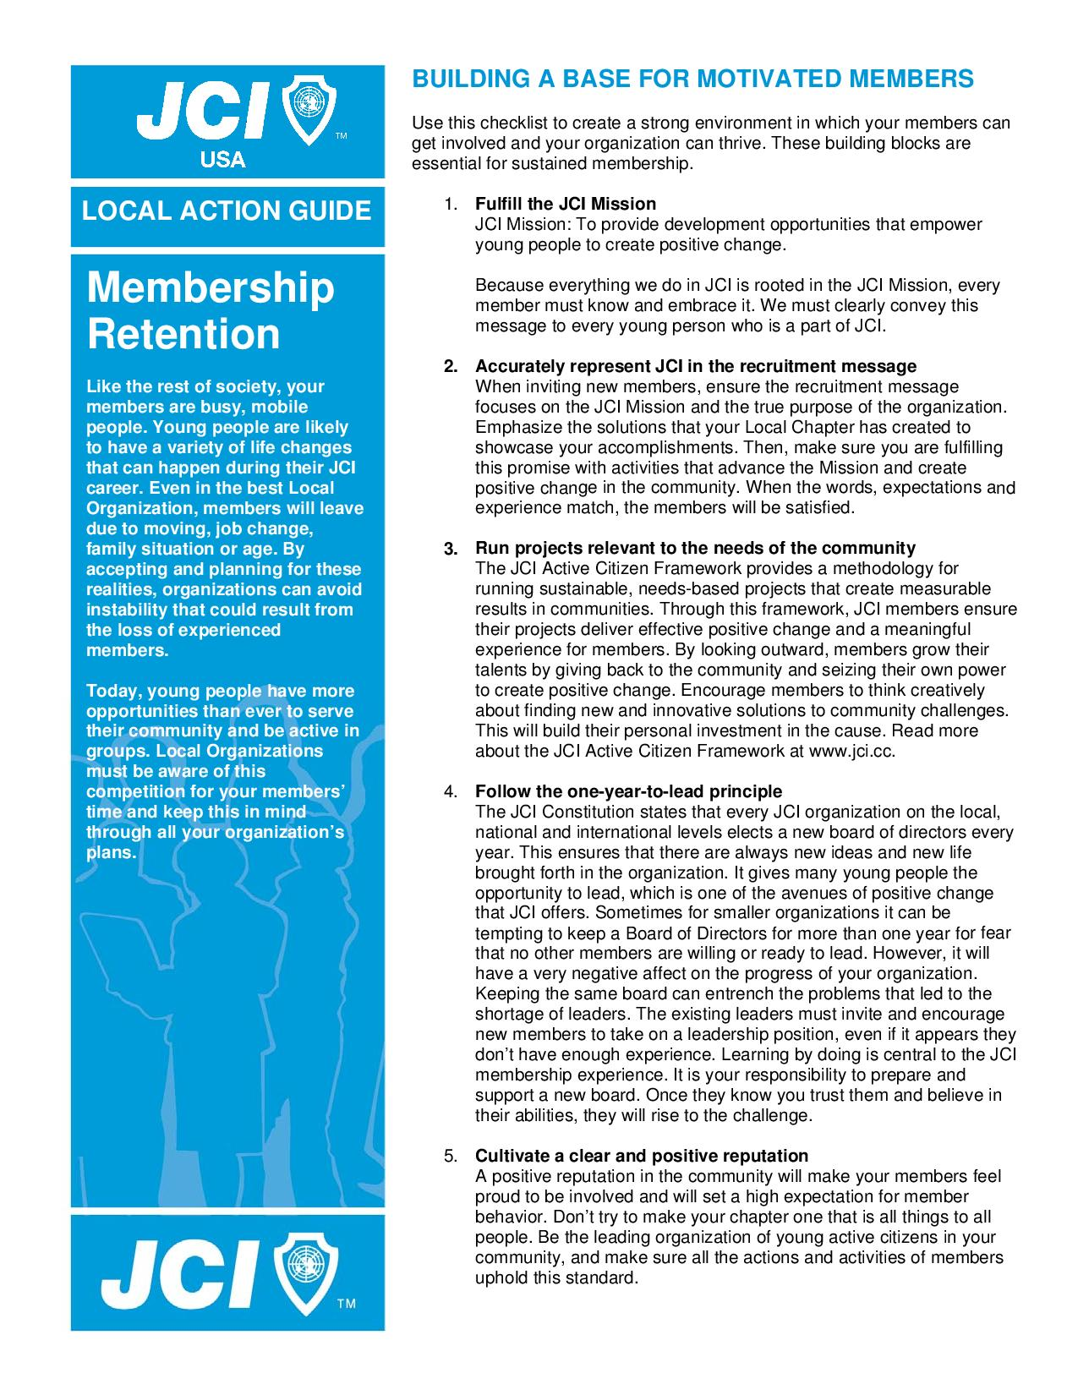
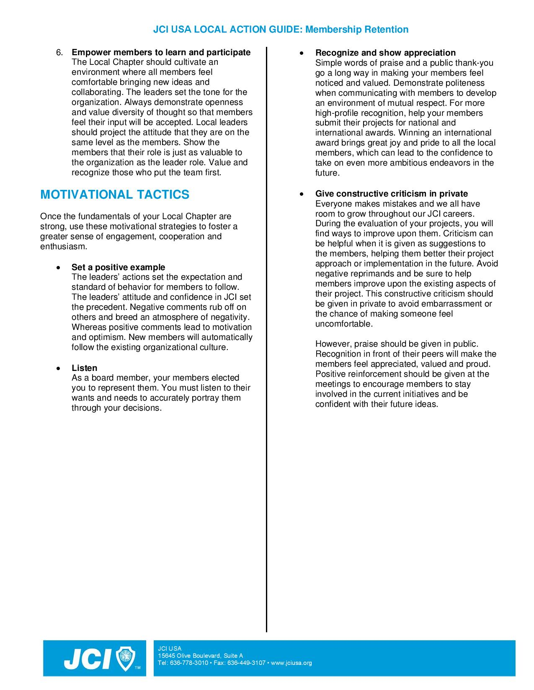
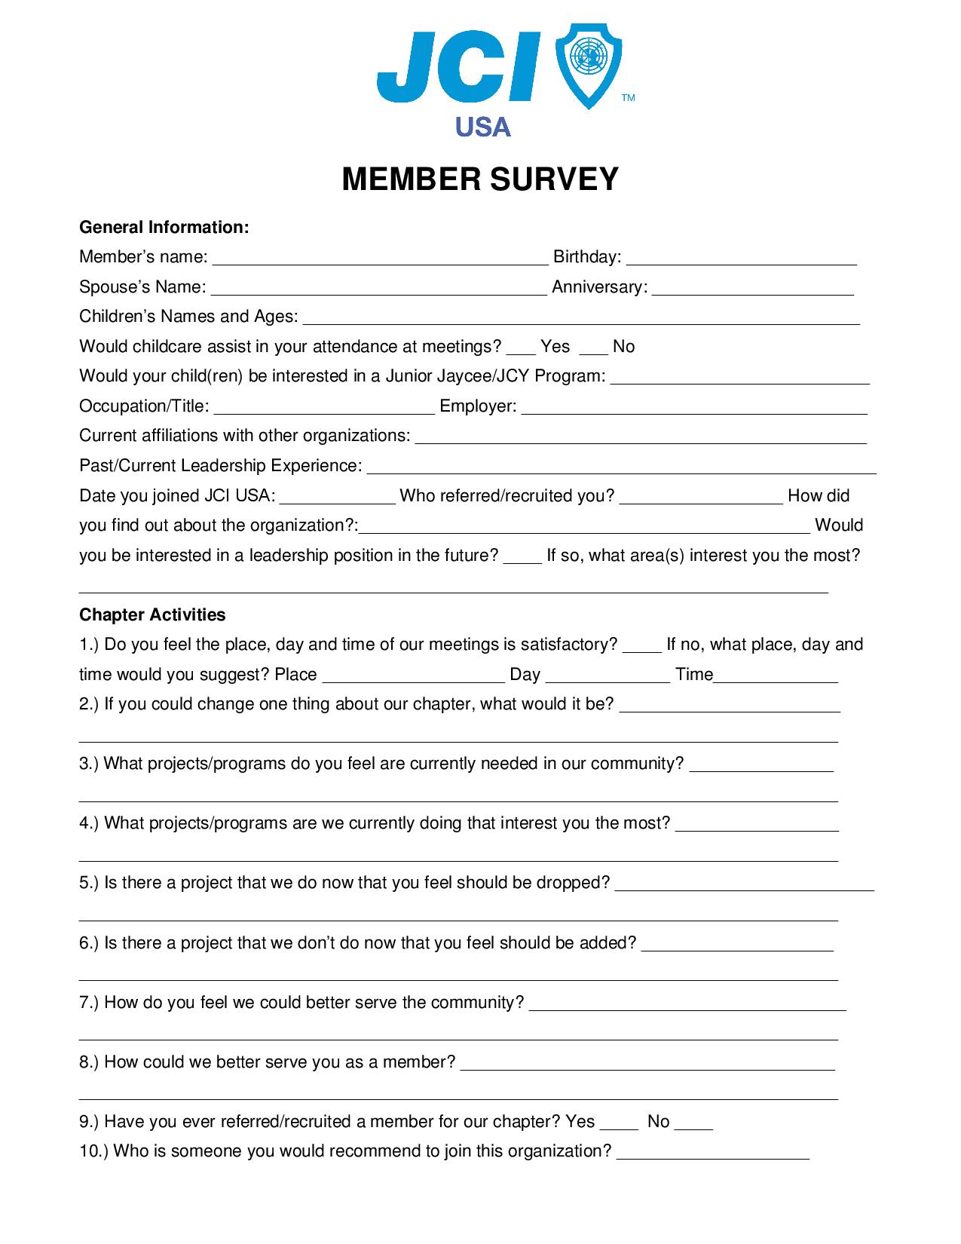
Chapter Membership Plan Form

THE [INSERT CHAPTER NAME] JAYCEES MEMBERSHIP PLAN

MONTH | Number  Members - | Number  Due = | Beginning  Month + | Number  Retained + | Number  New = | Month  End

January
February
March
April
May
June
July
August
September
October
November
December
Plan
Totals

ACTUAL
MONTH | Number  Members - | Number  Due = | Beginning  Month + | Number  Retained + | Number  New = | Month  End
January
February
March
April
May
June
July
August
September
October
November
December
Plan
Totals

