**Chapter Plan of Action**

**JCI Michigan**

**Chapter Name: ________________**

[ Insert Chapter Logo Here ]

**Semester Evaluations:**

| * Initial Submission Date: **February 28, 2025** |
| --- |
| * Semester 1 Evaluation Due Date: **July 11 2025** |
| * Semester 2/Year End/Final Evaluation Date: **Jan 9 2026** |

Contents

Chapter Plan Checklist 3

Resources 3

Additional information on SMART Goals planning: 3

Fundraising and Grant Resources: 3

Free Online Grant Writing Classes: 3

Top Giving Foundations in MI: 3

Chapter & Board of Directors Contact Information 4

Chapter Contact Information: 4

Board of Directors Contact Information: 4

Overview 5

Mission Statement 5

Vision Statement 5

Purpose Statement 5

Chapter SMART Goals 6

SMART Goals Explanation: 6

UN Sustainable Development Goals: 7

Chapter Objectives: 7

Programming 10

Membership Plan 11

How To Use The Membership Table/Spreadsheet: 11

Corrective Action Plan (For Chapters Under 20): 13

Surveys 14

Community Partnerships 14

Diversity, Equity and Inclusion (DE&I) Planning 14

Marketing Plan 15

Calendar of Events 17

Budget 20

# Chapter Plan Checklist

**☐** Chapter & Board of Directors Contact Information

**☐** Overview (Mission Statement, Vision Statement, Purpose Statement)

**☐** Chapter SMART Goals

**☐** Programming Plan

**☐** Membership Plan

**☐** Surveys

**☐** Community Partnerships Plan

**☐** Diversity, Equity, and Inclusion (DE&I) Plan

**☐** Marketing Plan

**☐** Calendar of Chapter Events

**☐** Budget

# Resources

## Additional information on SMART Goals planning:

* [The Ultimate Guide to S.M.A.R.T. Goals – Forbes Advisor](https://www.forbes.com/advisor/business/smart-goals/)
* [How to Set SMART Goals: Examples & Template | TeamGantt](https://www.youtube.com/watch?v=qxHDNKMDJrY&t=157s)

## Fundraising and Grant Resources:

* <https://www.michigan.gov/leo/boards-comms-councils/mcsc/nfr/funding/michigans-americorps-funding/grants-from-michigan-foundations-and-corporations>
* <https://www.grantwatch.com/grants-for-nonprofits>

## Free Online Grant Writing Classes:

* <https://www.nonprofitready.org/grant-writing-classes>
* <https://candid.org/>

## Top Giving Foundations in MI:

* <https://www.tgci.com/funding-sources/mi/top>
* [Grant Writing Made Easy Guide](https://docs.google.com/document/d/1kG_Hcg4Bm6EH4ajsimZItdKUXu_vscdPmUG7dIoAjm8/edit)
* [USJCCF_StateAndLocal_GrantApplication-0921.docx](https://docs.google.com/document/d/11NPsGODdj8lyNQ_dybtB5Ao5SOFNLzBaqfMcWvDyxiw/edit)

# Chapter & Board of Directors Contact Information

| Chapter Contact Information: | |
| --- | --- |
| Chapter Email: |  |
| Board of Directors Contact Information: (insert rows as necessary): | |
| President’s Name: |  |
| President Email: |  |
| President Phone Number: |  |
| Chairman of the Board Name: |  |
| Chairman of the Board Email: |  |
| Vice President Name: |  |
| Vice President Email: |  |
| Director Name: |  |
| Director Email: |  |
| Secretary Name: |  |
| Secretary Email: |  |
| Treasurer Name: |  |
| Treasurer Email: |  |

# Overview

## Mission Statement

Why do you exist?

## Vision Statement

What is your vision for your chapter?

## Purpose Statement

What is the purpose of your chapter? (You can use the JCI purpose statement).

# SMART Goals

## Explanation:

SMART Goals can be used by anyone to track progress and efficiency of goals.

S stands for Specific, which answers the five Ws: Who, What, When, Where, and Why? M stands for Measurable, which asks how you plan to determine that a goal has been reached. A stands for Achievable, which asks if the goal is attainable in your current state, and if not, how you can rise to meet it. R stands for Relevant, which asks if your goal is in line with the mission statement and objectives of JCI, but more specifically, your chapter. Finally, T stands for Time-Based, which asks if your goal has a specific deadline and what you can achieve in that time frame.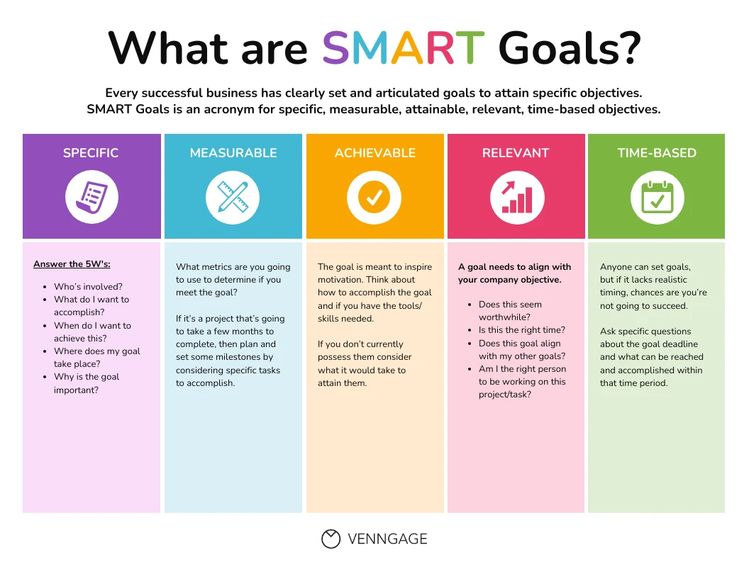

* **Example: Recruit new members.**
  + Specific: Recruit 10 new members.
  + Measurable: We will recruit 10 or more new members. If we recruit at least ten, we will have met the goal.
  + Achievable: It can be achievable if we work together as a team. We will use the Handbook suggestions, previous recruitment events that succeeded, and connect with potential recruits to help reach our goal.
  + Relevant: One of the main goals of JCI is to build leaders. If we as a chapter can give people the opportunity, we will be building leaders.
  + Time-Based: We have slightly less than a calendar year (until midnight December 31st, when the new Board of Directors takes charge) to recruit at least 10 members. This means that we should be recruiting around one person per month.

## UN Sustainable Development Goals:

JCI partners with the UN and has a project category for UN Sustainable Development Goal Projects. Below are the UN SDG’s to consider as you plan programming for the year.

As you are determining your chapter objectives, we encourage you to determine how the [UN Sustainable Development Goals](https://www.undp.org/content/undp/en/home/sustainable-development-goals.html#:~:text=The%20Sustainable%20Development%20Goals%20(SDGs,peace%20and%20prosperity%20by%202030.) fit into your chapter plan and projects (see chart below). Application, company name

## 

## 

## Chapter Objectives:

| **Goal #1** |  |
| --- | --- |
| **Specific** |  |
| **Measurable** |  |
| **Achievable** |  |
| **Relevant** |  |
| **Time-Based** |  |
| **Goal #2** |  |
| **Specific** |  |
| **Measurable** |  |
| **Achievable** |  |
| **Relevant** |  |
| **Time-Based** |  |
| **Goal #3** |  |
| **Specific** |  |
| **Measurable** |  |
| **Achievable** |  |
| **Relevant** |  |
| **Time-Based** |  |
| **Goal #4** |  |
| **Specific** |  |
| **Measurable** |  |
| **Achievable** |  |
| **Relevant** |  |
| **Time-Based** |  |
| **Goal #5** |  |
| **Specific** |  |
| **Measurable** |  |
| **Achievable** |  |
| **Relevant** |  |
| **Time-Based** |  |

# Programming

Use this as a template to structure your chapter’s programming for the year. Categories include Financial Development, Community, Individual, or Membership. (*Membership* means Recruitment, Activation, or Retention. *Individual* means focus on actual skills development in members.)

| **Project Title** | **Category** | **Month of Program** | | **Chair or Committee Members** | **Proposed Budget Income** | **Proposed Budget Expense** | **Proposed Net (Income – Expense)** |
| --- | --- | --- | --- | --- | --- | --- | --- |
|  |  | |  |  |  |  |  |
|  |  | |  |  |  |  |  |
|  |  | |  |  |  |  |  |
|  |  | |  |  |  |  |  |
|  |  | |  |  |  |  |  |
|  |  | |  |  |  |  |  |

Provide additional details as needed:

# Membership Plan

Use this Membership Plan to help understand your membership recruiting needs. Once your needs are identified then plan your calendar of events around those difficult months. For example: If you have a lot of members due in the second quarter, then your chapter should be running more programming this quarter prior and during to help offset members lost. For example – Socials, Community Fundraisers, Membership Drives, Networking Events, etc. Plan your calendar of events based off of this Membership Plan of Action.

## How To Use The Membership Table/Spreadsheet:

* Input your January 1 Base Chapter Member number in the box under the “No. Members” Column for Quarter 1. GlueUp doesn’t record your January 1st number, but the Membership and Programming Vice Presidents (Kimmy Black and Kayleigh Gratz) recorded base numbers for the entire state. Your base number is also required for Single Project Entry submissions and many awards.
* To pull monthly info, you can filter the roster in GlueUp to show expiration dates by month.
* Input the number of members that are up for renewal each month that you expect to retain their Jaycee membership in the “Number Retained” column.
* Input the number of new members you expect to gain each month.
* Insert the “Quarter End” number as the “No. Members” for the next month. (ie: If Month End = 20 for January, insert 20 for “No. Member” for February)
* The “Month End” number for December is the quantity of members you plan to have in the Chapter at the end of the year.

**Membership:**

| **Month** | **No.Members** | **- Number Due** | **+ Number Retained** | **+ New Members** | **= Month End** |
| --- | --- | --- | --- | --- | --- |
| Jan |  |  |  |  |  |
| Feb |  |  |  |  |  |
| Mar |  |  |  |  |  |
| Apr |  |  |  |  |  |
| May |  |  |  |  |  |
| Jun |  |  |  |  |  |
| Jul |  |  |  |  |  |
| Aug |  |  |  |  |  |
| Sep |  |  |  |  |  |
| Oct |  |  |  |  |  |
| Nov |  |  |  |  |  |
| Dec |  |  |  |  |  |

## 

## Corrective Action Plan (For Chapters Under 20):

If your chapter receives a notice from JCI USA for being under 20, you have the following options: to pay an invoice for outstanding members (~$30/member under 20, for example a chapter with 18 members owes $60), or submit a Corrective Action Plan.

The Corrective Action Plan should detail the steps you would take to bring your chapter up to 20 members in a 90-day span. Below is an example of a 90-day plan. The Corrective Action Plan should include a bit more detail (such as creating a Project Management Guide).

If you make progress but don’t get quite to 20 within the 90 days, you can submit a request to the National President for an extension.

| Month | Project | # of Potential Members Targeted | Beginning Number | Number Recruited as result | End Number |
| --- | --- | --- | --- | --- | --- |
| Jan | Bowling social | 5 | 12 | 3 | 15 |
| Feb | Encourage members to bring a friend to Skills Training | 8 | 15 | 1 | 16 |
| Mar | St Patrick’s Day Parade volunteers | 20 | 16 | 4 | 20 |

# Surveys

**Needs of Membership**

What did you learn from your membership survey? Things to consider answering: What are your members hoping to accomplish this year? What types of projects do they want to run? Why are they members of your chapter? The Membership Handbook on jcimi.org has examples of a membership survey. Enter results here.

# 

# Needs of Community

Conduct a community survey. This can be as easy as a google form QR code at the info table at a project. Ask things such as what types of community events one would be more inclined to attend, their age bracket, and if they would be interested in learning more about JCI (ask for contact info with this!). Enter results here.

# 

# Community Partnerships

**Goals for utilizing community partnerships this year:** Are you looking for new sponsors? Planning a project that relies on involvement from city government or local businesses? Have a fundraiser in mind to help a specific nonprofit?

**Existing Community Partnerships:** List here

**Community Entities to Partner With:** List here

**Diversity, Equity and Inclusion (DE&I) Planning**

What organizations exist in your area? (Examples: Veteran Associations, LGBTQ+ owned businesses, etc.)

* Company 1
* Company 2
* Company 3

How can you partner with these organizations?

* Company 1 (Same as above): Info on how will partner
* Company 2 (Same as above): Info on how will partner
* Company 3 (Same as above): Info on how will partner

How do you plan to implement Diversity, Equity and Inclusion at your chapter?

# Marketing Plan

***Goals:***

***Branding Development:***

Ex. Increase name/logo awareness within community

***Social Media:***

Ex. Post multiple times a week, engage members and community

***Communications Channels:***

Ex. How do you community with members, the community, partners

## *Calendar of Marketing:*

Table is just an example.

| **Event** | **Date** |
| --- | --- |
| Print Business Cards | January 2025 |
| Mail Sponsorship Letters | March-May 2025 |
| Order New T-Shirts and Nametags for Members | March |
| **Monthly Meeting Promotion** | ongoing monthly |
| Set up Facebook Event | Beginning of 2025 |
| Set up MeetUp Event | Beginning of 2025 |
|  |  |
| **Internal FB Group Promotion** | various |
| Set up Facebook Event | at least 2 weeks prior |
| Set up MeetUp Event | at least 2 weeks prior |
|  |  |
| **Large Community Event** | March 7, 2025 |
| Set Up Facebook Event | February |
| Set Up MeetUp Event | February |

## 

## *Communications Plan:*

Table is just an example.

|  | **Deliverable** | **Description** | **Delivery Method** | **Frequency** | **Owner** | **Audience** |
| --- | --- | --- | --- | --- | --- | --- |
| **Internal** | Monthly Meeting | Meeting to discuss upcoming projects and events, guest speaker | Meeting | Monthly | President | General Members and Guests |
| Needs of Membership | Survey of the Social, Community, Operations, Membership needs of the Chapter | Survey | Annually | President | General Members |
| Newsletter | Official Newsletter of the Ann Arbor Jaycees | Mailchimp/Email/GlueUp Campaign | Monthly | Newsletter Editor / COB | General Members |
| Board of Director Meeting Minutes | Minutes from recent meeting | Email | Monthly | President / COB | Board of Directors |
| New Member Orientations | Orientation about the Chapter to new members | Meeting | Quarterly | Membership Vice President | New Members |
| Updates | Updates about new members, monthly meetings, other events | Email | ≥ Monthly | President | General Members |
| Projects and Events | Community, Social, Fundraising, State Events | Email/Crier/ Social Media / Text | ≥ Monthly | President/Crier Editor/VPs/Committee Chairs | General Members and Potential Members |
| **External** | Social Events | Promotion and Updates | Email/ Meeting /Social Media/News Publications/ Phone Calls | Weekly | Project Chair |  |
| Community Events | Promotion, updates, and ticket sales | Email/ Meeting /Social Media/News | Variable | Committee |  |

# Calendar of Events

Insert your Meetings, Events, and Project Dates accordingly. If dates are unknown, list “TBD” in the appropriate month.

| **Calendar Year: 2025** | |
| --- | --- |
| **January** | |
| Date: | Event/Project Title: |
| Date: | Event/Project Title: |
| Date: | Event/Project Title: |
| **February** | |
| Date: | Event/Project Title: |
| Date: | Event/Project Title: |
| Date: | Event/Project Title: |
| **March** | |
| Date: | Event/Project Title: |
| Date: | Event/Project Title: |
| Date: | Event/Project Title: |
| **April** | |
| Date: | Event/Project Title: |
| Date: | Event/Project Title: |
| Date: | Event/Project Title: |
| Date: | Event/Project Title: |
| **May** | |
| Date: | Event/Project Title: |
| Date: | Event/Project Title: |
| Date: | Event/Project Title: |
| Date: | Event/Project Title: |
| **June** | |
| Date: | Event/Project Title: |
| Date: | Event/Project Title: |
| Date: | Event/Project Title: |
| **July** | |
| Date: | Event/Project Title: |
| Date: | Event/Project Title: |
| Date: | Event/Project Title: |
| **August** | |
| Date: | Event/Project Title: |
| Date: | Event/Project Title: |
| Date: | Event/Project Title: |
| **September** | |
| Date: | Event/Project Title: |
| Date: | Event/Project Title: |
| Date: | Event/Project Title: |
| Date: | Event/Project Title: |
| **October** | |
| Date: | Event/Project Title: |
| Date: | Event/Project Title: |
| Date: | Event/Project Title: |
| Date: | Event/Project Title: |
| **November** | |
| Date: | Event/Project Title: |
| Date: | Event/Project Title: |
| Date: | Event/Project Title: |
| **December** | |
| Date: | Event/Project Title: |
| Date: | Event/Project Title: |
| Date: | Event/Project Title: |

# Budget

Below is an example of a budget. Feel free to use this template, insert your own, or attach an excel document.

|  | **INCOME** | **EXPENSE** |
| --- | --- | --- |
| **BUSINESS** |  |  |
| Business-related Projects |  |  |
| Leadership Projects |  |  |
| Ways & Means Projects |  |  |
| Member Dues |  |  |
| Corporate Sponsorships |  |  |
| Insurance, Incorporation, Taxes, Audit |  |  |
| Public Relations |  |  |
| Chapter Newsletter & Brochure |  |  |
| Chapter Website & Hosting |  |  |
| Chamber of Commerce Membership Dues |  |  |
| Surveys |  |  |
| Miscellaneous Operations |  |  |
| **TOTAL:** |  |  |
| **Membership** |  |  |
| Financial Planning Projects |  |  |
| Personal Skills Projects |  |  |
| Family Life Projects |  |  |
| Spiritual Development Projects |  |  |
| Chapter Socials |  |  |
| Chapter Awards |  |  |
| Write-Up/Speak-Up/Armbruster/Brownfield/Debate |  |  |
| Membership Recruitment |  |  |
| New Member Orientations |  |  |
| New Member Packets |  |  |
| Recruiting Incentives |  |  |
| Membership Training |  |  |
| Officer Training |  |  |
| Printing for Meetings |  |  |
| Miscellaneous Operations |  |  |
| **TOTAL:** |  |  |
| **COMMUNITY** |  |  |
| Community Service Projects |  |  |
| Community Fundraising Projects |  |  |
| Governmental Involvement Projects |  |  |
| Children & Youth Projects |  |  |
| Miscellaneous Operations |  |  |
| **TOTAL:** |  |  |
| **Other** |  |  |
| State & National Involvement Projects |  |  |
| International Involvement Projects |  |  |
| Miscellaneous Operations |  |  |
| **TOTAL:** |  |  |
| **GRAND TOTAL:** |  |  |

# 

**STOP!**

(To be evaluated on a quarterly basis. Please include revised objectives, key results, and initiatives. – Replace text with aforementioned criteria – you may want to color code your quarters for easier reference)

**Quarter 1**

**Quarter 2**

**Quarter 3**

**Year End/Final Evaluation**