Chapter Plan of Action



Chapter Name: ________________

[ Insert Chapter Logo Here ]

Chapter Plan Evaluations:
- Initial Submission Date: February 28, 2026
- Chapter Internal Q1 Evaluation: March 31, 2026
- Mid-Year State Evaluation Submission Due Date: July 11, 2026
- Chapter Internal Q3 Evaluation: September 30, 2026
- Year End/Final State Evaluation Submission Date: Jan 8, 2027

Contents
Chapter Plan Checklist 3
Resources 3
Additional information on SMART Goals planning: 3
Fundraising and Grant Resources: 3
Free Online Grant Writing Classes: 3
Top Giving Foundations in MI: 3
Chapter & Board of Directors Contact Information 4
Chapter Contact Information: 4
Board of Directors Contact Information: 4
Overview 5
Mission Statement 5
Vision Statement 5
Purpose Statement 5
Chapter SMART Goals 6
SMART Goals Explanation: 6
UN Sustainable Development Goals: 7
Chapter Objectives: 7
Programming 10
Membership Plan 11
How To Use The Membership Table/Spreadsheet: 11
Corrective Action Plan (For Chapters Under 20): 13
Surveys 14
Community Partnerships 14
Diversity, Equity and Inclusion (DE&I) Planning 14
Marketing Plan 15
Calendar of Events 17
Budget 20

Chapter Plan Checklist

☐ Chapter & Board of Directors Contact Information
☐ Overview (Mission Statement, Vision Statement, Purpose Statement)
☐ Chapter SMART Goals
☐ Programming Plan
☐ Membership Plan
☐ Surveys
☐ Community Partnerships Plan
☐ Diversity, Equity, and Inclusion (DE&I) Plan
☐ Marketing Plan
☐ Calendar of Chapter Events
☐ Budget
☐ Constitution/Bylaws
☐ Articles of Incorporation
☐ Chapter Insurance
☐ Most Recent IRS Form 990 Submissions

Resources

Additional information on SMART Goals planning:
- The Ultimate Guide to S.M.A.R.T. Goals – Forbes Advisor
- How to Set SMART Goals: Examples & Template | TeamGantt

Fundraising and Grant Resources:
- https://www.michigan.gov/leo/boards-comms-councils/mcsc/nfr/funding/michigans-americorps-funding/grants-from-michigan-foundations-and-corporations
- https://www.grantwatch.com/grants-for-nonprofits

Free Online Grant Writing Classes:
- https://www.nonprofitready.org/grant-writing-classes
- https://candid.org/

Top Giving Foundations in MI:
- https://www.tgci.com/funding-sources/mi/top
- Grant Writing Made Easy Guide
- USJCCF_StateAndLocal_GrantApplication-0921.docx

Chapter & Board of Directors Contact Information

Chapter Contact Information:
Chapter Email:

Board of Directors Contact Information:
(insert rows as necessary):
President’s Name:
President Email:
President Phone Number:
Chairman of the Board Name:
Chairman of the Board Email:
Vice President Name:
Vice President Email:
Director Name:
Director Email:
Secretary Name:
Secretary Email:
Treasurer Name:
Treasurer Email:

Overview

Mission Statement
Why do you exist?

Vision Statement
What is your vision for your chapter?

Purpose Statement
What is the purpose of your chapter? (You can use the JCI purpose statement).

SMART Goals

Explanation:
SMART Goals can be used by anyone to track progress and efficiency of goals.
S stands for Specific, which answers the five Ws: Who, What, When, Where, and Why? M stands for Measurable, which asks how you plan to determine that a goal has been reached. A stands for Achievable, which asks if the goal is attainable in your current state, and if not, how you can rise to meet it. R stands for Relevant, which asks if your goal is in line with the mission statement and objectives of JCI, but more specifically, your chapter. Finally, T stands for Time-Based, which asks if your goal has a specific deadline and what you can achieve in that time frame.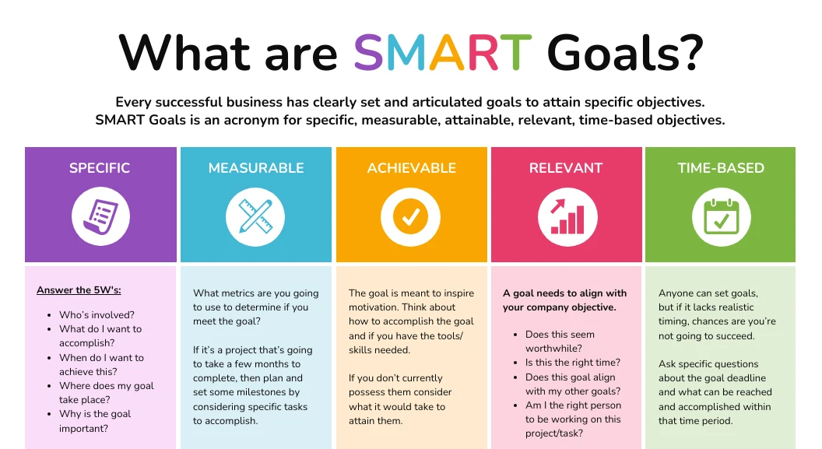

- Example: Recruit new members.
  - Specific: Recruit 10 new members.
  - Measurable: We will recruit 10 or more new members. If we recruit at least ten, we will have met the goal.
  - Achievable: It can be achievable if we work together as a team. We will use the Handbook suggestions, previous recruitment events that succeeded, and connect with potential recruits to help reach our goal.
  - Relevant: One of the main goals of JCI is to build leaders. If we as a chapter can give people the opportunity, we will be building leaders.
  - Time-Based: We have slightly less than a calendar year (until midnight December 31st, when the new Board of Directors takes charge) to recruit at least 10 members. This means that we should be recruiting around one person per month.

UN Sustainable Development Goals:
JCI partners with the UN and has a project category for UN Sustainable Development Goal Projects. Below are the UN SDG’s to consider as you plan programming for the year.
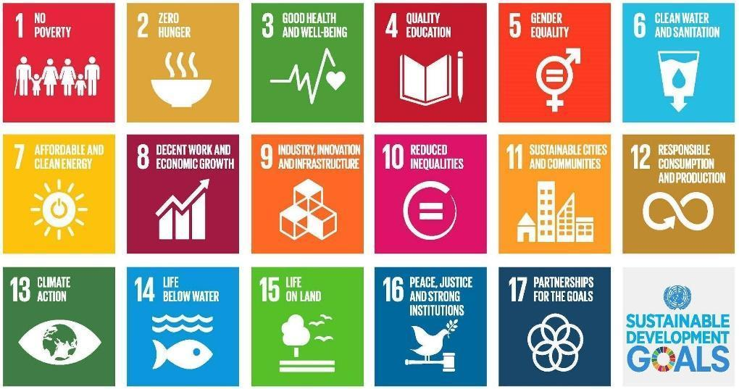
As you are determining your chapter objectives, we encourage you to determine how the UN Sustainable Development Goals fit into your chapter plan and projects (see chart below).

Chapter Objectives:
Goal #1
Specific
Measurable
Achievable
Relevant
Time-Based
Goal #2
Specific
Measurable
Achievable
Relevant
Time-Based
Goal #3
Specific
Measurable
Achievable
Relevant
Time-Based
Goal #4
Specific
Measurable
Achievable
Relevant
Time-Based
Goal #5
Specific
Measurable
Achievable
Relevant
Time-Based

Programming
Use this as a template to structure your chapter’s programming for the year. Categories include Financial Development, Community, Individual, or Membership. (Membership means Recruitment, Activation, or Retention. Individual means focus on actual skills development in members.)
Project Title | Category | Month of Program |  | Chair or Committee Members | Proposed Budget Income | Proposed Budget Expense | Proposed Net (Income – Expense)

Provide additional details as needed:

Membership Plan
Use this Membership Plan to help understand your membership recruiting needs. Once your needs are identified then plan your calendar of events around those difficult months. For example: If you have a lot of members due in the second quarter, then your chapter should be running more programming this quarter prior and during to help offset members lost. For example – Socials, Community Fundraisers, Membership Drives, Networking Events, etc. Plan your calendar of events based off of this Membership Plan of Action.

How To Use The Membership Table/Spreadsheet:
- Input your January 1 Base Chapter Member number in the box under the “No. Members” Column for Quarter 1. GlueUp doesn’t record your January 1st number, but the Membership and Programming Vice Presidents (Kimmy Black and Kayleigh Gratz) recorded base numbers for the entire state. Your base number is also required for Single Project Entry submissions and many awards.
- To pull monthly info, you can filter the roster in GlueUp to show expiration dates by month.
- Input the number of members that are up for renewal each month that you expect to retain their Jaycee membership in the “Number Retained” column.
- Input the number of new members you expect to gain each month.
- Insert the “Quarter End” number as the “No. Members” for the next month. (ie: If Month End = 20 for January, insert 20 for “No. Member” for February)
- The “Month End” number for December is the quantity of members you plan to have in the Chapter at the end of the year.

Membership:
Month | No.Members | - Number Due | + Number Retained | + New Members | = Month End
Jan
Feb
Mar
Apr
May
Jun
Jul
Aug
Sep
Oct
Nov
Dec

Corrective Action Plan (For Chapters Under 20):
If your chapter receives a notice from JCI USA for being under 20, you have the following options: to pay an invoice for outstanding members (~$30/member under 20, for example a chapter with 18 members owes $60), or submit a Corrective Action Plan.

The Corrective Action Plan should detail the steps you would take to bring your chapter up to 20 members in a 90-day span. Below is an example of a 90-day plan. The Corrective Action Plan should include a bit more detail (such as creating a Project Management Guide).

If you make progress but don’t get quite to 20 within the 90 days, you can submit a request to the National President for an extension.

Month | Project | # of Potential Members Targeted | Beginning Number | Number Recruited as result | End Number
Jan | Bowling social | 5 | 12 | 3 | 15
Feb | Encourage members to bring a friend to Skills Training | 8 | 15 | 1 | 16
Mar | St Patrick’s Day Parade volunteers | 20 | 16 | 4 | 20

Surveys
Needs of Membership
What did you learn from your membership survey? Things to consider answering: What are your members hoping to accomplish this year? What types of projects do they want to run? Why are they members of your chapter? The Membership Handbook on jcimi.org has examples of a membership survey. Enter results here.

Needs of Community
Conduct a community survey. This can be as easy as a google form QR code at the info table at a project. Ask things such as what types of community events one would be more inclined to attend, their age bracket, and if they would be interested in learning more about JCI (ask for contact info with this!). Enter results here.

Community Partnerships
Goals for utilizing community partnerships this year: Are you looking for new sponsors? Planning a project that relies on involvement from city government or local businesses? Have a fundraiser in mind to help a specific nonprofit?
Existing Community Partnerships: List here
Community Entities to Partner With: List here

Diversity, Equity and Inclusion (DE&I) Planning
What organizations exist in your area? (Examples: Veteran Associations, LGBTQ+ owned businesses, etc.)
- Company 1
- Company 2
- Company 3
How can you partner with these organizations?
- Company 1 (Same as above): Info on how will partner
- Company 2 (Same as above): Info on how will partner
- Company 3 (Same as above): Info on how will partner
How do you plan to implement Diversity, Equity and Inclusion at your chapter?

Marketing Plan
Goals:

Branding Development:
Ex. Increase name/logo awareness within community

Social Media:
Ex. Post multiple times a week, engage members and community

Communications Channels:
Ex. How do you community with members, the community, partners

Calendar of Marketing:
Table is just an example.
Event | Date
Print Business Cards | January 2025
Mail Sponsorship Letters | March-May 2025
Order New T-Shirts and Nametags for Members | March
Monthly Meeting Promotion | ongoing monthly
Set up Facebook Event | Beginning of 2025
Set up MeetUp Event | Beginning of 2025
Internal FB Group Promotion | various
Set up Facebook Event | at least 2 weeks prior
Set up MeetUp Event | at least 2 weeks prior
Large Community Event | March 7, 2025
Set Up Facebook Event | February
Set Up MeetUp Event | February

Communications Plan:
Table is just an example.

 | Deliverable | Description | Delivery Method | Frequency | Owner | Audience
Internal | Monthly Meeting | Meeting to discuss upcoming projects and events, guest speaker | Meeting | Monthly | President | General Members and Guests
Internal | Needs of Membership | Survey of the Social, Community, Operations, Membership needs of the Chapter | Survey | Annually | President | General Members
Internal | Newsletter | Official Newsletter of the Ann Arbor Jaycees | Mailchimp/Email/GlueUp Campaign | Monthly | Newsletter Editor / COB | General Members
Internal | Board of Director Meeting Minutes | Minutes from recent meeting | Email | Monthly | President / COB | Board of Directors
Internal | New Member Orientations | Orientation about the Chapter to new members | Meeting | Quarterly | Membership Vice President | New Members
Internal | Updates | Updates about new members, monthly meetings, other events | Email | ≥ Monthly | President | General Members
Internal | Projects and Events | Community, Social, Fundraising, State Events | Email/Crier/ Social Media / Text | ≥ Monthly | President/Crier Editor/VPs/Committee Chairs | General Members and Potential Members
External | Social Events | Promotion and Updates | Email/ Meeting /Social Media/News Publications/ Phone Calls | Weekly | Project Chair
External | Community Events | Promotion, updates, and ticket sales | Email/ Meeting /Social Media/News | Variable | Committee

Calendar of Events
Insert your Meetings, Events, and Project Dates accordingly. If dates are unknown, list “TBD” in the appropriate month.
Calendar Year: 2025
January
Date: | Event/Project Title:
Date: | Event/Project Title:
Date: | Event/Project Title:
February
Date: | Event/Project Title:
Date: | Event/Project Title:
Date: | Event/Project Title:
March
Date: | Event/Project Title:
Date: | Event/Project Title:
Date: | Event/Project Title:
April
Date: | Event/Project Title:
Date: | Event/Project Title:
Date: | Event/Project Title:
Date: | Event/Project Title:
May
Date: | Event/Project Title:
Date: | Event/Project Title:
Date: | Event/Project Title:
Date: | Event/Project Title:
June
Date: | Event/Project Title:
Date: | Event/Project Title:
Date: | Event/Project Title:
July
Date: | Event/Project Title:
Date: | Event/Project Title:
Date: | Event/Project Title:
August
Date: | Event/Project Title:
Date: | Event/Project Title:
Date: | Event/Project Title:
September
Date: | Event/Project Title:
Date: | Event/Project Title:
Date: | Event/Project Title:
Date: | Event/Project Title:
October
Date: | Event/Project Title:
Date: | Event/Project Title:
Date: | Event/Project Title:
Date: | Event/Project Title:
November
Date: | Event/Project Title:
Date: | Event/Project Title:
Date: | Event/Project Title:
December
Date: | Event/Project Title:
Date: | Event/Project Title:
Date: | Event/Project Title:

Budget
Below is an example of a budget. Feel free to use this template, insert your own, or attach an excel document.
 | INCOME | EXPENSE
BUSINESS
Business-related Projects
Leadership Projects
Ways & Means Projects
Member Dues
Corporate Sponsorships
Insurance, Incorporation, Taxes, Audit
Public Relations
Chapter Newsletter & Brochure
Chapter Website & Hosting
Chamber of Commerce Membership Dues
Surveys
Miscellaneous Operations
TOTAL:
Membership
Financial Planning Projects
Personal Skills Projects
Family Life Projects
Spiritual Development Projects
Chapter Socials
Chapter Awards
Write-Up/Speak-Up/Armbruster/Brownfield/Debate
Membership Recruitment
New Member Orientations
New Member Packets
Recruiting Incentives
Membership Training
Officer Training
Printing for Meetings
Miscellaneous Operations
TOTAL:
COMMUNITY
Community Service Projects
Community Fundraising Projects
Governmental Involvement Projects
Children & Youth Projects
Miscellaneous Operations
TOTAL:
Other
State & National Involvement Projects
International Involvement Projects
Miscellaneous Operations
TOTAL:
GRAND TOTAL:

STOP!

(To be evaluated on a quarterly basis. Please include revised objectives, key results, and initiatives. – Replace text with aforementioned criteria – you may want to color code your quarters for easier reference)

Quarter 1

Quarter 2

Quarter 3

Year End/Final Evaluation

